1. **Create one vpc in N.virginia region.**

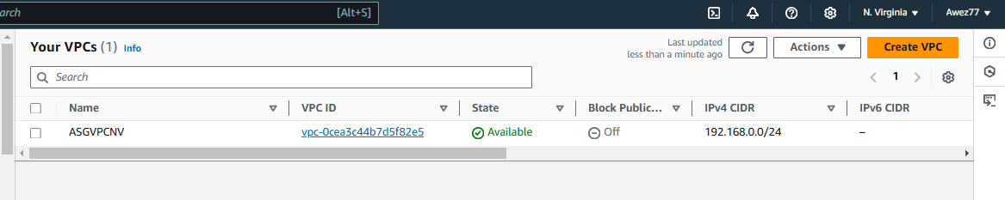

1. **Create two subnets. One Public subnet and one private subnet.**

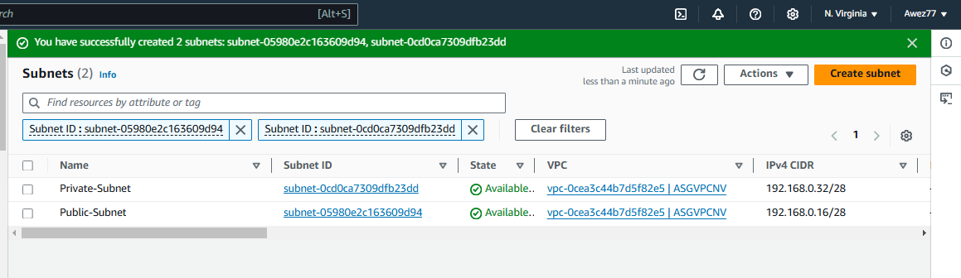

1. **Provide the IGW to the vpc.**

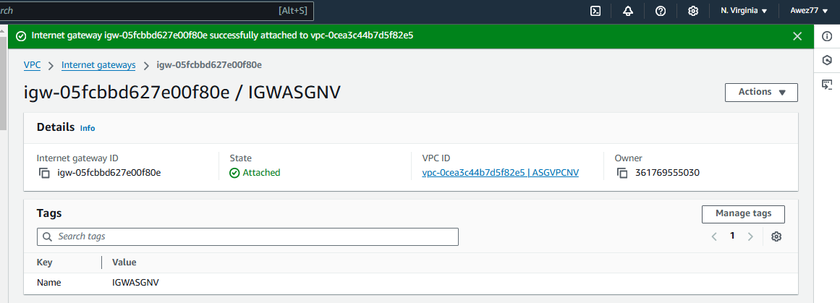

1. **Create One public RT and one private RT.**

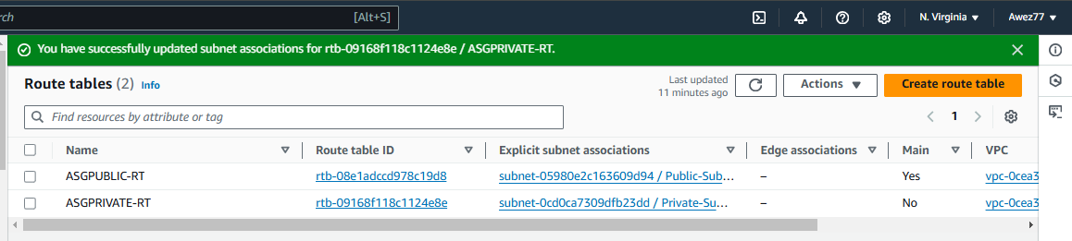

1. **Deploy NAT gateway on public subnet and attach the NAT gatewat to private subnet.**

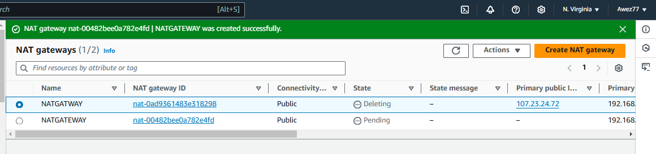

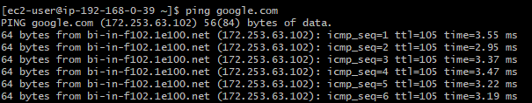

1. **Create Two instances,one in public subnet and one in private subnet.**

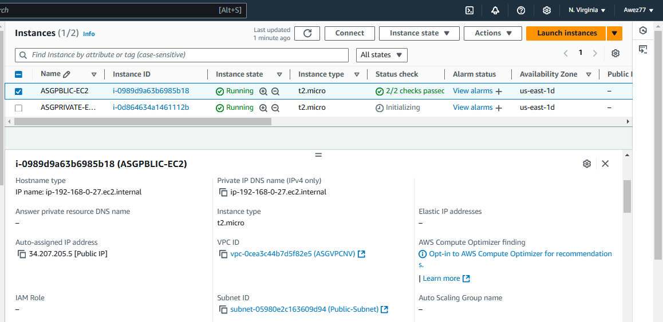

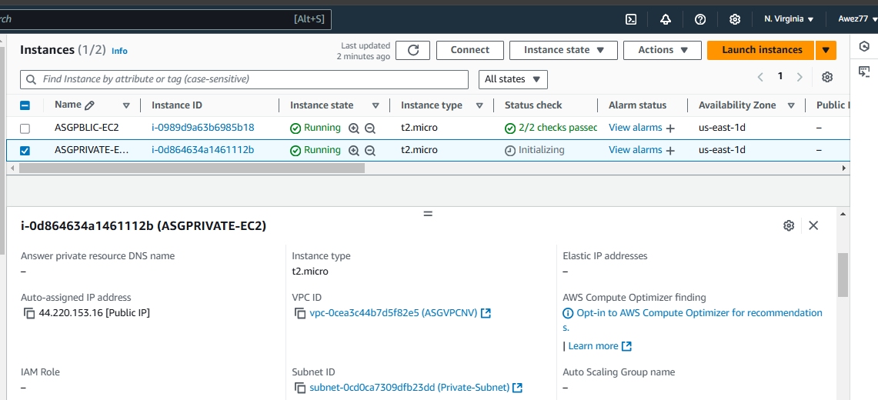

1. **Deploy Apache server on both the ec2 instances with sample index.html file.**

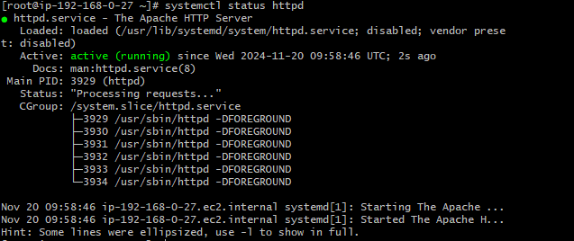

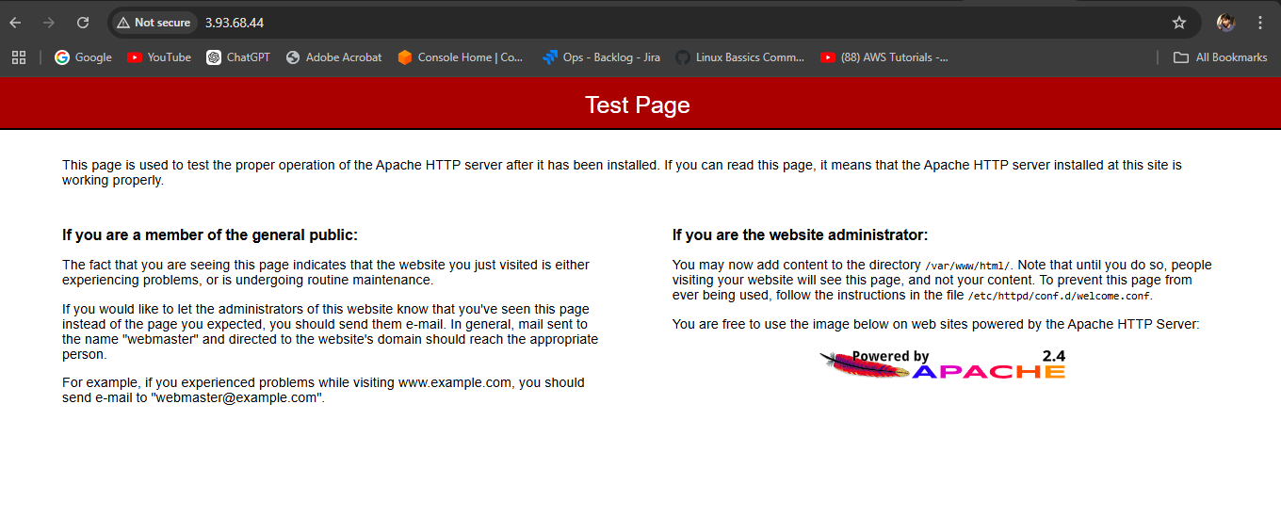

1. **Create one application load balancer and attach the load balancer to both the ec2 instances.**

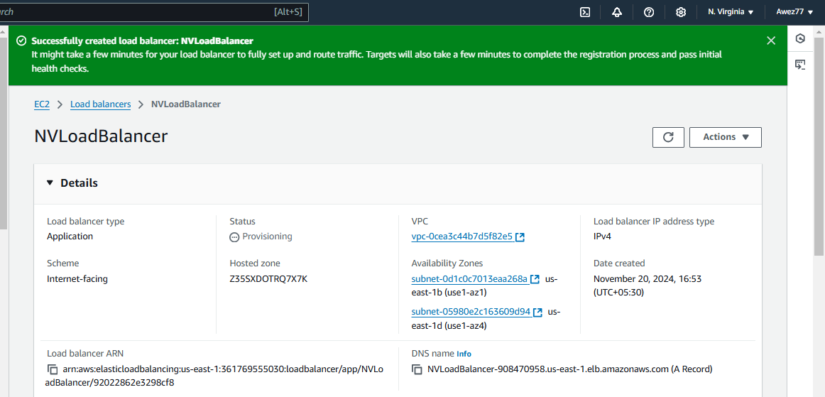

1. **Store Application load balancer logs to s3.**

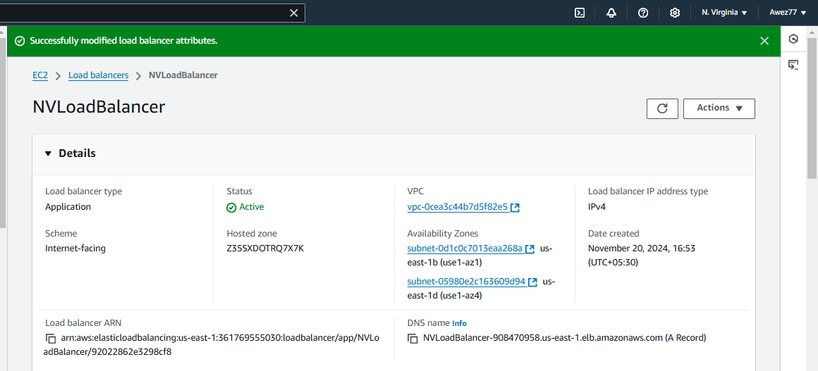

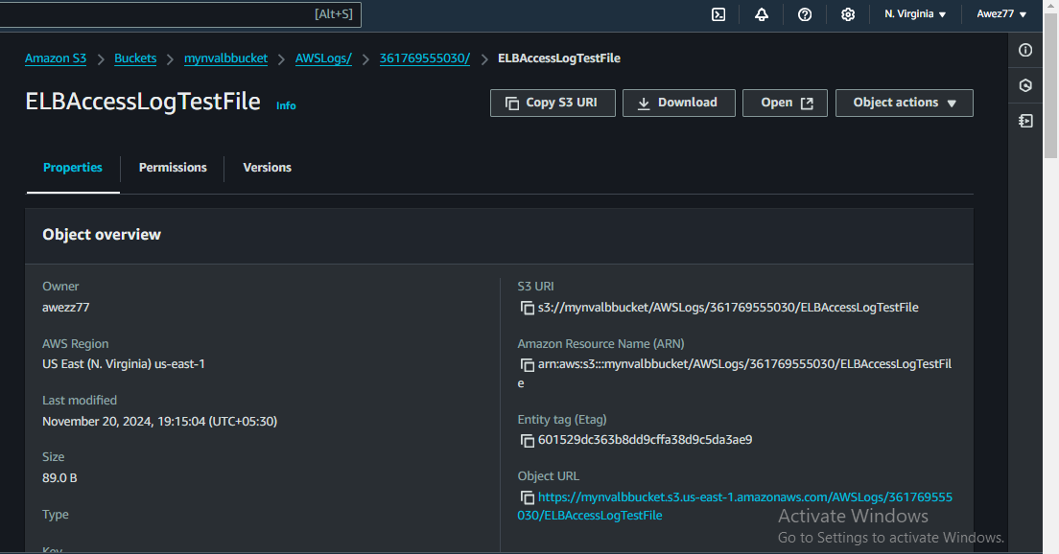

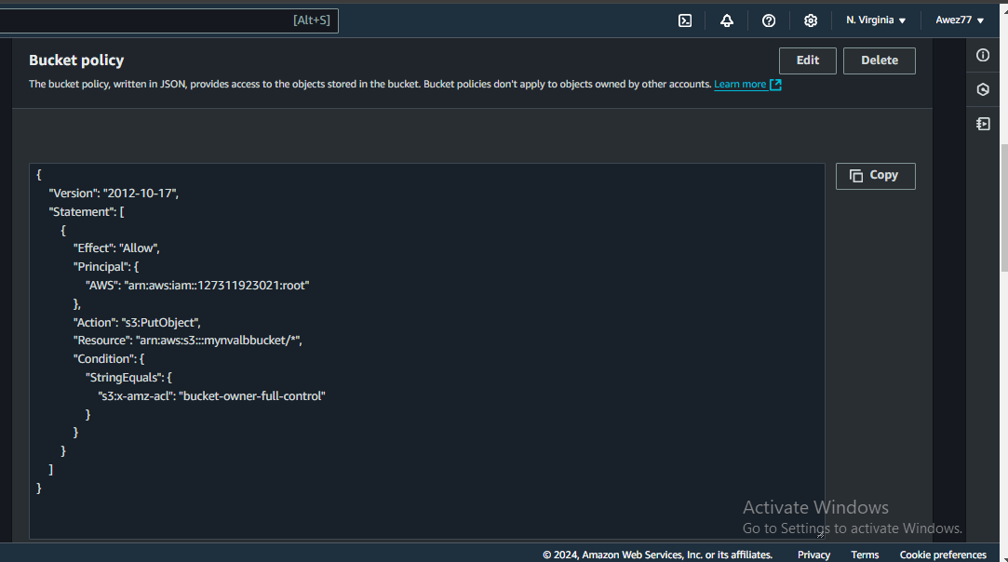

1. **Store the vpc flow logs to cloudwtach group.**

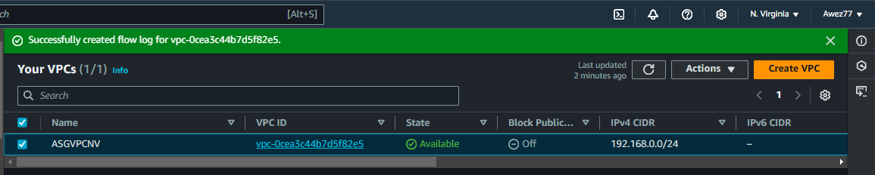

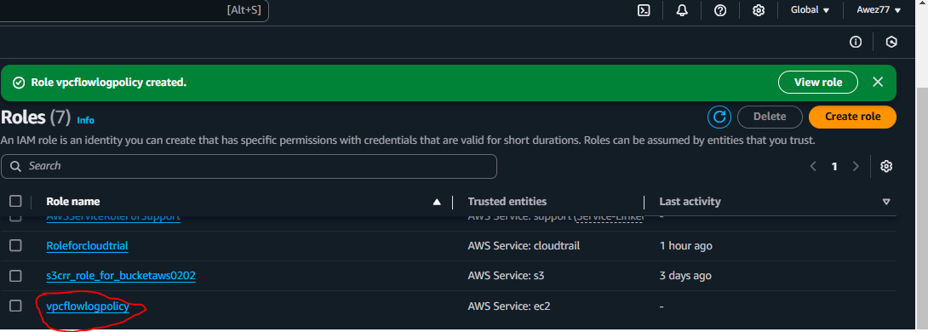

1. **Create Monitoring Dashboards to monitor cpu utilization and to monitor apache service.**

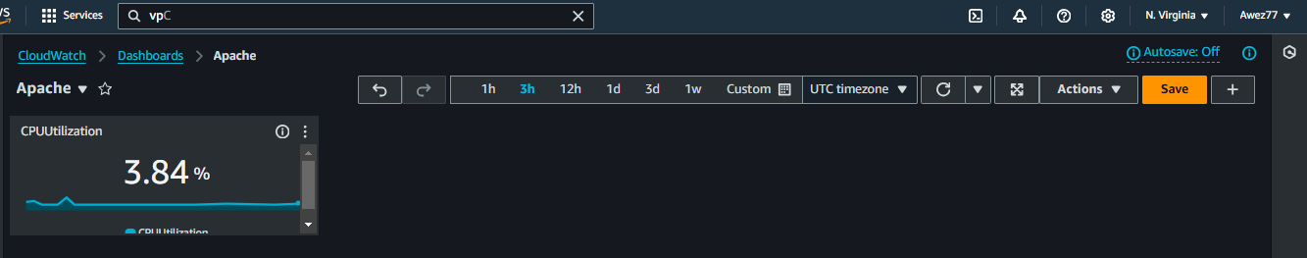

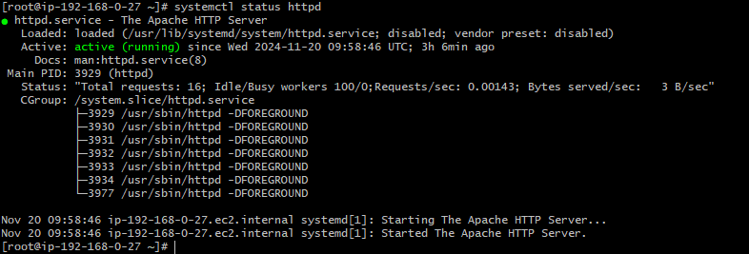

1. **CPU utilizationis more than 70% then it should triggere Autoscaling and launch new instance.**

